**CentOS Install**

* Power on the the virtual machine associated with the CentOS iso file and begin the installation process for CentOS.

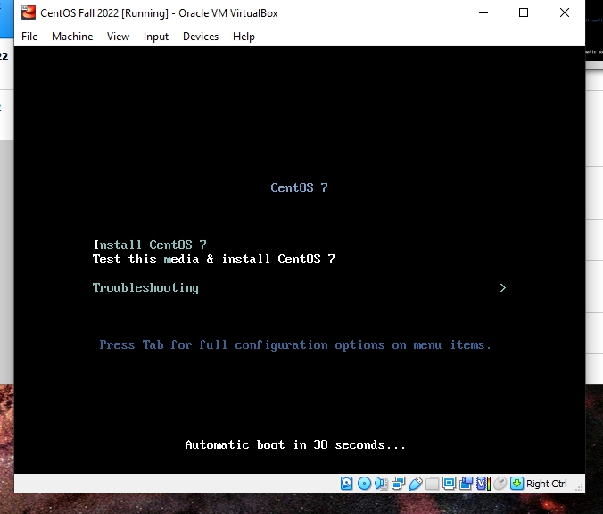

* Go through the basics such as language choice, keyboard preferences, date/time and other basic settings.

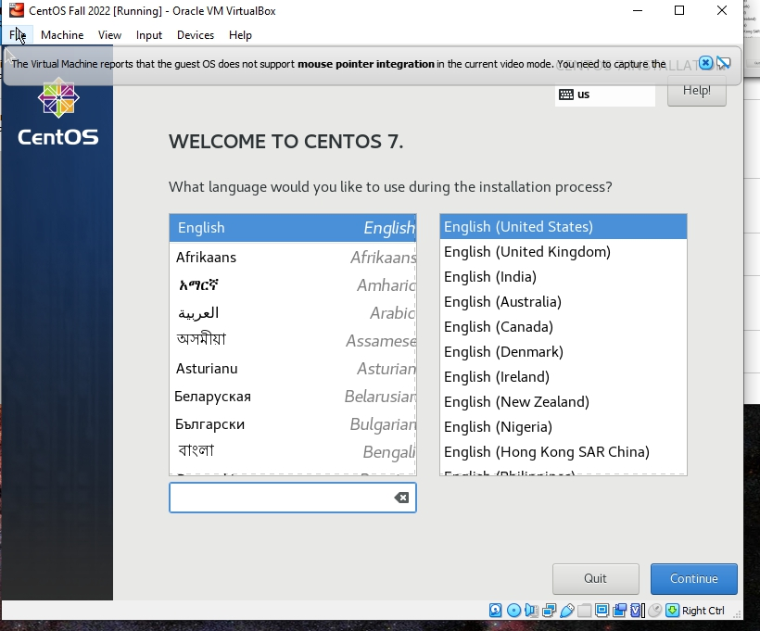

* Once you reach this screen, click on the ‘Network and Host Name’ option located under System.

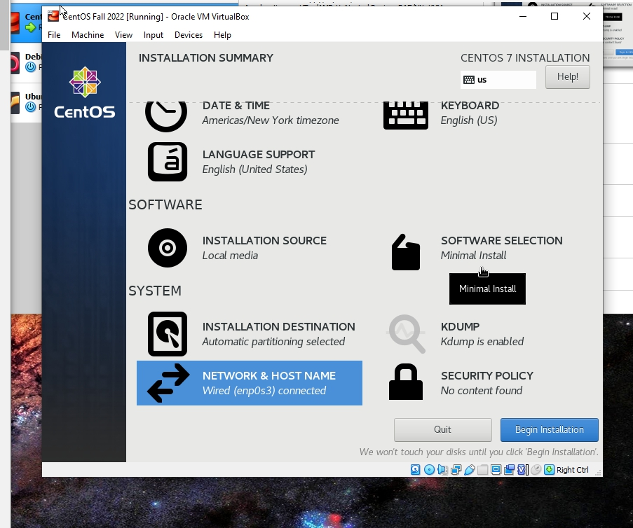

* Ensure the network connection is set to the on position. (Circled below)

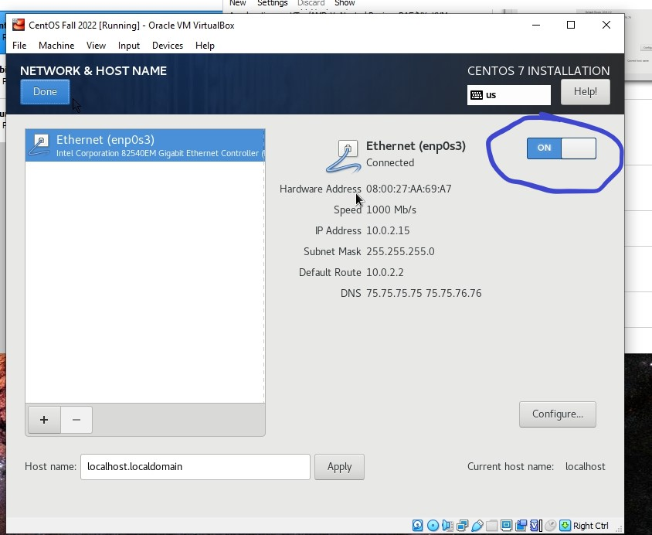

* Next you will make a new user, choose a password that you will remember and is secure. I chose to give this new user administrator privileges (optional).

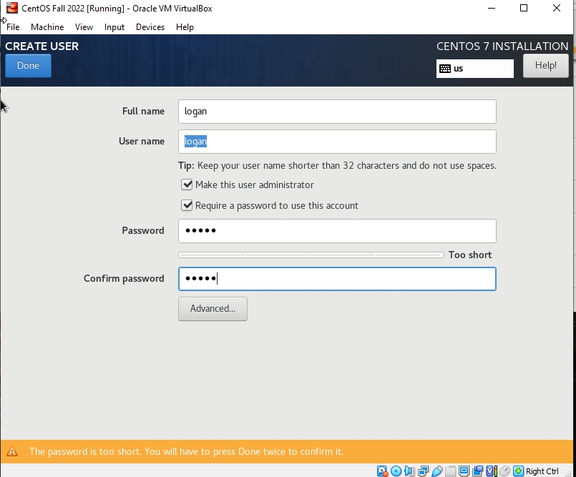

* Choose a password for the root user. The root user has admin privileges, so ensure that the password is secure. After this the installation will begin. When it is finished, click Reboot in the bottom right of the screen and proceed to the next step.

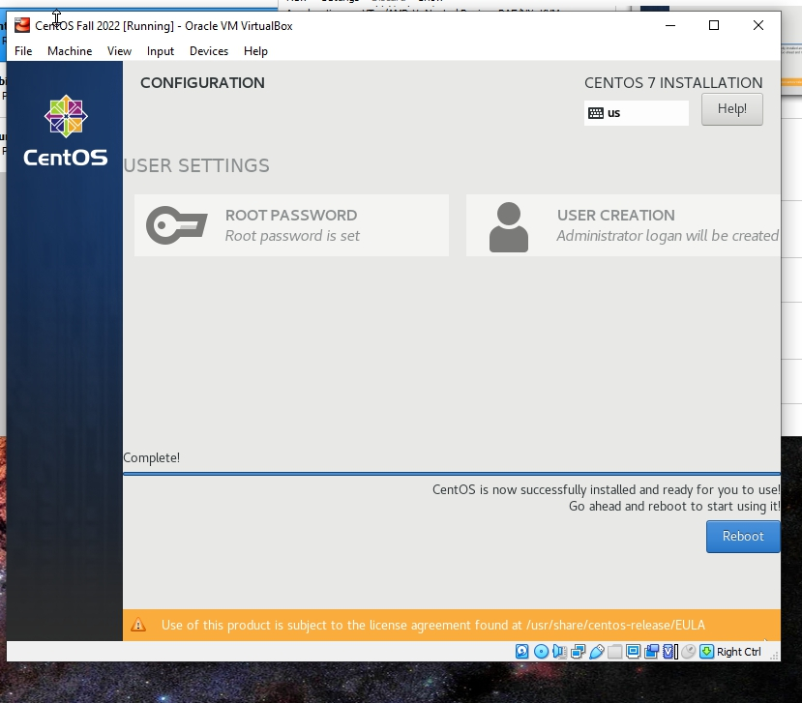

* After the system reboots, select the option to boot into CentOS Linux (3.10.0)

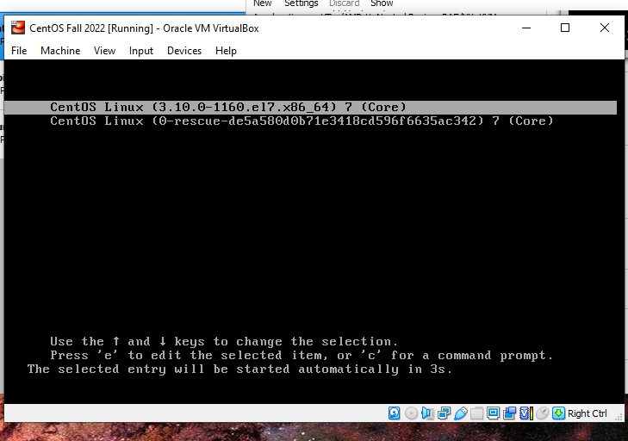

* Login with the root and password user you created, then run the command “yum install net-tools. This will enable network interface commands like ifconfig, to ensure we have an established internet connection.

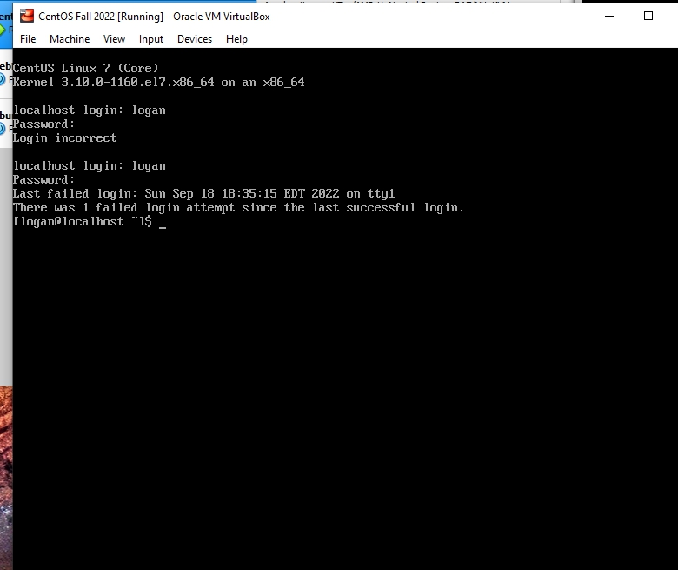

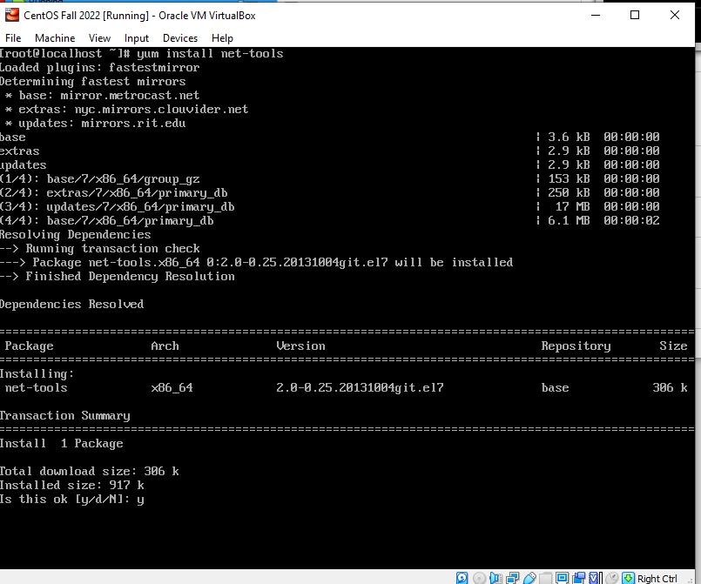

* Run the command ifconfig to determine network status.

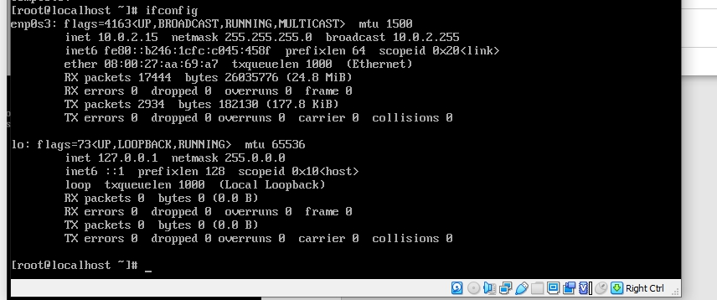

* Run the command “sudo yum -y install openssh-server openssh-clients”. SSH is a network protocol that gives users a secure way to access a computer remotely, move files from one computer to another, and strong password authentication.

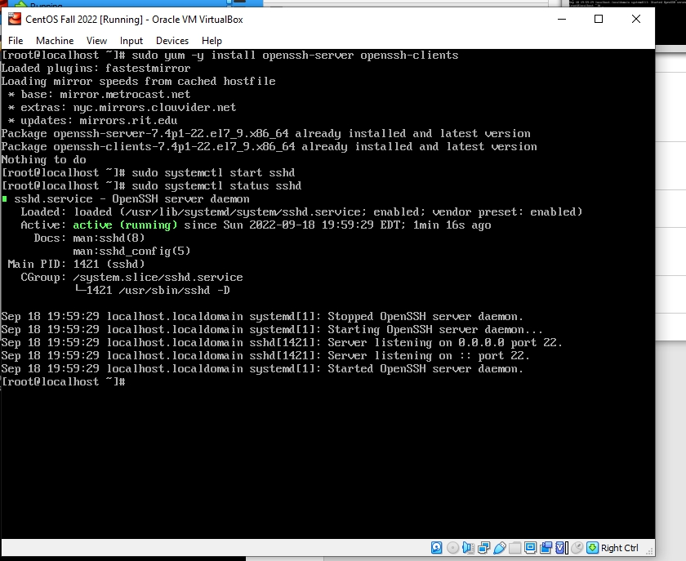

* Run the command “sudo systemect1 status sshd” – this will start the SSH process. Then run “sudo systemect1 status sshd” – this command shows the status of the SSH process and confirms it is working correctly.